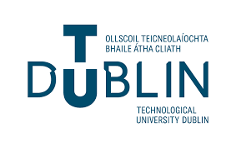

Final Year Project Proposal

TU858

Sign & Spell VR: ISL Alphabet Practice and Sentence Construction in Virtual Reality

Karl Negrillo
C22386123

School of Computer Science
TU Dublin – City Campus

12/09/2025

Table of Contents
Contents
Table of Contents i
Declaration ii
Summary 1
Background (and References) 1
Proposed Approach 2
Deliverables 4
Project Schedule 5
Technical Requirements 6
Conclusion 6
References R1
Appendix A: First Project Review A2
Appendix B: Second Project Review B1
Appendix C: Prompts Used with ChatGPT C1
Appendix D: D1

Declaration

I hereby declare that the work described in this dissertation is, except where otherwise stated, entirely my own work and has not been submitted as an exercise for a degree at this or any other university.

Signed:

Karl Negrillo___________________
Karl Negrillo

12/09/2025

Summary
What is the Project idea?
My project is called Sign & Spell VR. It’s a virtual reality application that helps people learn Irish Sign Language (ISL) in an interactive, fun, and educational way. The idea is to let users go from learning ISL to spelling words, forming short sentences, and finally taking a small test to check what they’ve learned. It will run on the Meta Quest 3 provided in the XR Prototyping Module using Godot 4, and it tracks the user’s hand movements in real time to see if they are signing correctly.

Why is it useful/unique?
Most sign language learning tools focus on American Sign Language (ASL) and use videos or simple 2D animations. This project is different because it focuses on ISL and uses VR hand tracking so learning can practice in a 3D Environment. It also gives real-time feedback and doesn’t rely on machine learning, which keeps it fast and reliable. Later versions could add ML for better recognition and translation.

What does it offer (e.g., To the User)?
It offers users a way to practice ISL interactively instead of just watching videos. They can learn letters and words, combine them to make short sentences, and get feedback on how accurate their signs are. There’s also a test mode that checks what they remember and tracks their progress.

How will it Operate?
The app uses hand tracking from the Meta Quest 3, and the code will come from Godot 4. A simple rule-based compares hand positions to stored ISL sign templates. All the signs, words, and sentences are stored in JSON files, which makes it easier to update or expand later.

Why is this a good idea and what will the end deliverable be?
This project is a good idea because there aren’t many tools for learning ISL, especially in VR. It’s inclusive, educational, and uses modern technology in a useful way. The final deliverable will be a working VR Prototype where users can learn, practice, and test their ISL knowledge through interactive lessons and feedback.

Background (and References)
What is the background for this type of project?
Learning sign language is important for communication and inclusion, but it can be difficult for beginners to learn on their own. Many people use books, online videos, or take ISL classes from the Irish Deaf Society. While classes provide feedback, books and videos don’t correct mistakes. The app ASL Fingerspeller on SideQuest notes that VR and hand tracking make learning “more immersive and interactive,” showing how new technology can make signing more engaging [1]. VR allows users to move in a 3D environment, helping them better understand hand shapes and motion.

This project is also important because there are very few tools for learning Irish Sign Language (ISL). Most existing apps focus on American Sign Language (ASL), which uses one hand. ISL uses two hands and different grammar rules, so it needs its own learning tools. A VR-based ISL system could make learning more accessible and inclusive for the Deaf community in Ireland.

Are there any similar solutions (existing solutions or research)?
Some VR apps already teach sign language, but mostly ASL. For example, ASL Fingerspeller [1] lets users spell words in VR, and Silent Classroom VR [2] offers a classroom-style setup. ASL Champ! [3] uses AI for real-time feedback, but these apps don’t include sentence practice or ISL content.

In Ireland, DEF-ISL [4] and CrowdSign exist, but they mainly show static videos or pictures with no interaction. The study Design of Sign Language Learning Media Based on Virtual Reality developed an interactive VR sign language app with visual feedback and found users gained confidence after using it [5].

For any of your project’s features is there any research that can help guide the feasibility/implementation?
Since this project uses Godot, features like OpenXR or controller gestures can be handled through rule-based detection instead of machine learning. Novaliendry et al. [5] describe using “a software testing technique that focuses on the functionality of the software without considering its internal structure or implementation details,” which suits early-stage testing in Godot. Research also shows that VR learners perform better with “immediate and interactive feedback” [3]. The video VR Sign Language Learning with Hand Tracking [6] demonstrates how visual feedback helps users correct signs in real time. Together, these findings suggest a rule-based, feedback-driven VR system is both feasible and effective for teaching ISL.

Proposed Approach
How do you plan to complete this Project?
For my project Sign & Spell VR, my plan to complete it is using the Agile Method, structured into five main areas: Research, Requirements Gathering, Analysis and Design, Implementation, and Testing/Evaluation. With this approach, it is flexible, has continuous testing, and refining. This is essential for a prototype that will combine VR, hand-tracking, and interactive learning.

5 Main Areas to my Research:

Research
I will begin my project with a focused research phase that will make the technical, educational, and design foundation for the system. This will include existing sign language apps such as ASL Fingerspell, Silent Classroom VR, and DEF-ISL to check what they do well and where they fall short, like interactivity, feedback, and inclusiveness.
- My research will cover:
  - ISL-specific material, including resources from the Irish Deaf Society, to ensure accuracy of hand shapes and grammar from sentences.
  - VR Hand-Tracking technology on the Meta Quest 3, focusing on what data points are accessible through the Godot 4 OpenXR plugin.
  - Rule-based recognition approaches, evaluating how gesture templates can be compared to real-time hand data without requiring machine learning.

Requirements Gathering
I will be identifying both the functional and non-functional requirements. The functional requirement will define what the app must do, such as detecting the hand poses, guiding the user through lessons (showing random words to sign and showing sentences to sign), and giving instant feedback. The non-functional requirements will define how it will perform, such as smooth frame rate, accessible visual feedback, and running comfortably on the Meta Quest 3 headset.
- User Group
  - For this project, I will get a small user group composed of ISL learners, interpreters, or peers. I will be consulting them to ensure the app aligns with real learning needs. Their feedback will help share early prototypes and lesson designs. Since this is a prototype, user feedback will include focus on usability, learning clarity, and the help of the feedback system rather than perfect linguistic coverage.

Analysis and Design
For my design, I will convert research findings and requirements into a clear architecture. Using UML and flow diagrams, I can map out the scope of the project. Mapping the system will be turned into these logical components:
- Input Layer: this captures hand data from the Meta Quest 3
- Recognition System: compares tracked hand poses against pre-defined ISL templates stored in a JSON File.
- Feedback System: Displays visual and textual responses based on gesture accuracy.
- Test System: Test the user without looking back at the ISL alphabet to check accuracy and feedback where they need to learn more on.

Testing/Evaluating
For my testing and evaluation, it will take place continuously throughout development and conclude with a formal assessment.

Testing will verify gesture recognition accuracy, frame rate stability, and responsiveness within the Meta Quest 3 headset. I will be doing iterative testing at the end of its development sprint to identify bugs, improve feedback precision, and ensure smooth user interaction.

Evaluation will focus on the effectiveness of the implementation of Test Mode as a learning and assessment tool. A small group of ISL learners or peers will use the app and provide feedback on usability, comfort, and clarity of visual feedback.

For my results, it will guide my refinements and validate whether the system is effective and supports ISL learning in a VR environment.

Deliverables
The deliverables for my project will demonstrate the development of the project and the functionality of the working prototype. This will align with the research objectives, Agile Development approach, and testing outcomes.

Project Deliveries
- Functional VR Prototype
  - A working Sign & Spell VR app developed in Godot 4 and deployed on the Meta Quest 3 headset.
  - Core Features:
    - ISL Alphabet Learning and Practice using hand-tracking and gesture recognition
    - Word and Sentence Signing Module
    - Test Mode that evaluates user signing accuracy and provides feedback
- Documentation
  - Detailed report outlining the system architecture, class structure, staying on the scope, and hand-tracking logic used.
  - UML Diagrams and flowcharts illustrating input handling, recognition logic, and feedback system
  - Instruction for setup and deployment, including any dependencies or configuration steps.
- User Evaluation Result
  - Summary of testing outcomes
  - Feedback from the user group regarding usability, accuracy, and learning impact.
  - System strengths and weaknesses, and improvements.
- Final Report/Dissertation
  - Documenting the whole project.
  - Challenged faced, decisions made, and comparison to related work
  - Future Development
- Source Code and Assets
  - Complete code in Godot using GDScript with commented lines on the code
  - JSON data files for ISL sign templates
  - 3D or UI assets created or changed during development
  - Sharing and storing on GitHub.
- Demonstration Video
  - Short demonstration of how to use the app.

Project Schedule
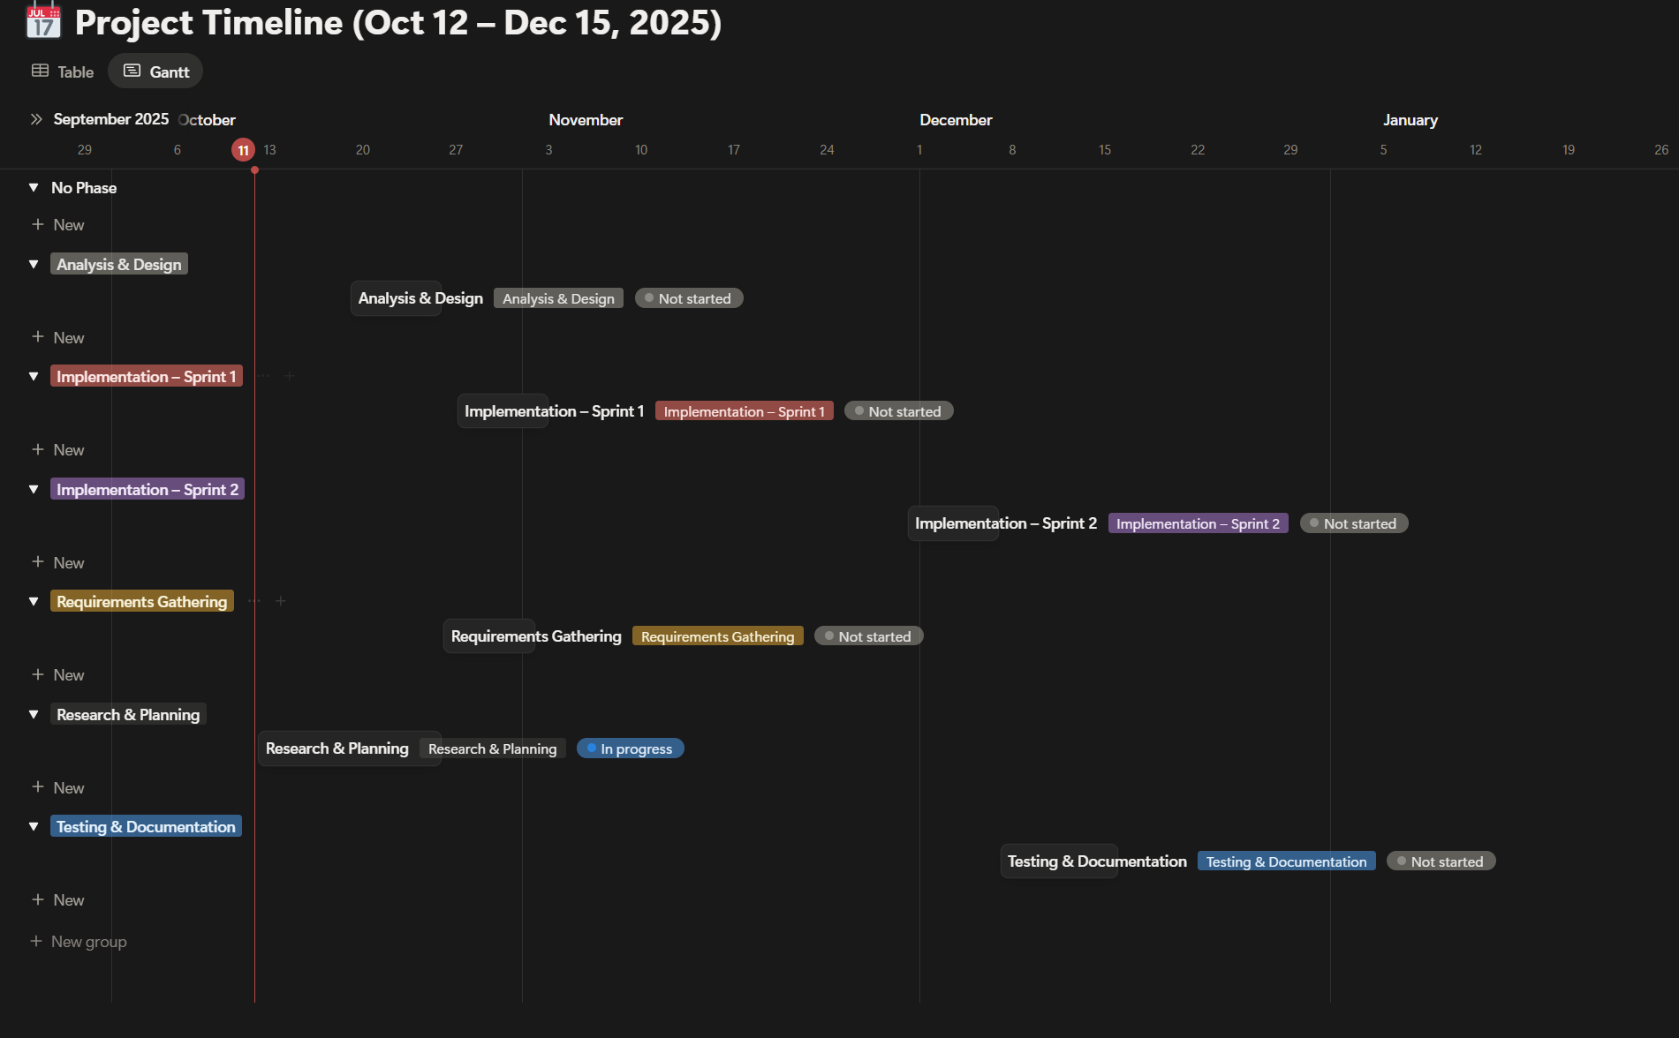

Gantt Chart till Progress for Final Year Project in December:

Research & Planning (Oct 12 – Oct 25, 2025):
Researching ISL materials, existing VR sign-learning tools, explore Godot 4 and OpenXR, understand how hand tracking works. Apply the scope.

Analysis & Design (Oct 19 – Oct 25, 2025):
Create UML Diagrams, plan how JSON files will store ISL sign data, UI for the app.

Requirements Gathering (Oct 26 – Nov 1, 2025, Reading Week):
List main features for the app, define what user should be able to do.

Implementation – Sprint 1 (Oct 27 – Nov 2, 2025, Reading Week):
Set up GitHub, Godot 4 and integrate OpenXR plugin, use the headset and do hand-tracking, add the ISL alphabet

Implementation – Sprint 2 (Nov 30 – Dec 6, 2025):
Build ISL recognition system using store gesture templates, create easy real-time feedback for correct and incorrect signs.

Testing & Documentation (Dec 7 – Dec 15, 2025):
Test hand-tracking accuracy, collect peer feedback for basic implementation, video demo of progession.

Technical Requirements
For development and testing on Sign & Spell VR, I need a few pieces of hardware and software to make and test everything properly.

For Hardware, I’ll be using the Meta Quest 3 provided by the module XR Prototyping. This will run and test the VR app, along with my laptop or any PC that can handle VR development.

For Software, I will be using Godot 4 with OpenXR plugin for hand-tracking. I’ll also use GitHub to save my work and keep track of changes.

Once built, the app will run directly on the Meta Quest 3 without needing an internet connection.

Conclusion
To sum up, Sign & Spell VR is a virtual reality application designed to help people learn Irish Sign Language (ISL) in an interactive and engaging way. It will use the Meta Quest 3’s hand-tracking feature to let users practice real ISL signs and get instant feedback. The project will aim to make ISL easier and more enjoyable by combining education and modern technology. The outcome will be a working prototype that includes learning, practice, and test modes. Overall, I will show how VR can be used for accessibility and education while filling the gap in ISL learning tools available today.

References
[1] ASL Fingerspeller – SideQuest. Available: https://sidequestvr.com/app/1317/asl-fingerspeller
[2] Silent Classroom VR – Meta. Available: https://www.meta.com/experiences/silent-classroom-asl-vr/9249215595132131/
[3] ASL Champ! – ScienceDirect. Available: https://www.sciencedirect.com/science/article/pii/S2949678024000096?

[4] DEF-ISL – App Store. Available: https://apps.apple.com/mt/app/def-isl/id6447841373
[5] D. Novaliendry et al., “Design of Sign Language Learning Media Based on Virtual Reality,” Int. J. Online Biomedical Engineering (iJOE), vol. 19, no. 16, pp. 111–126, 2023.
https://www.researchgate.net/publication/375642351_Design_of_Sign_Language_Learning_Media_Based_on_Virtual_Reality

[6] VR Sign Language Learning with Hand Tracking [Video]. YouTube, 2023. Available: https://youtu.be/HeFut3Htrcw

Appendix A: First Project Review
Title: Sign Language Translator (SLT)

Student: Andrei Botnari

Description (brief): This project is about creating a system that is capable of translating Irish Sign Language (ISL) gestures into text using the Xbox Kinect Sensor. This student developed a recognition pipeline that captured depth data, segmented the hands from the background, and matched the input against predefined gestures. From this project, the aim is to evaluate the accuracy the Kinect sensor under different environmental conditions such as lighting, distance, and motion.

What is complex in this project: The real time gestures recognition using low-resolution depth data. From the project, ISL contains many hand shapes that appear visually similar, making classification and tracking difficult. Managing environmental interference and differentiating between similar gestures (e.g., E, S, and T) required careful calibration and algorithm tuning.

What technical architecture was used: The student used the Kinect V2 depth sensor connected to a PC and developed in Python and C#. This project followed the Spiral Development model, which emphasises the iterative testing of gesture recognition accuracy and usability. The architecture included modules like image capture, segmentation, and features extraction before translating gestures to text output.

Explain key strengths and weaknesses of this project, as you see it:
Strengths: Hard focus on experimental validation, detailed testing across varied conditions. The spiral model ensured improvements. It provided an early exploration into ISL recognition, which remains a niche and research area.
Weaknesses: This project depended heavy on the Kinect hardware, which is now outdated and sensitive to lighting and distance as the resolution is low. It lacked interactive feedback, which means that users could not correct or practice signs dynamically, which limits learning effectiveness.

Appendix B: Second Project Review
Title: VR Music Learner

Student: Maciej Golubski

Description (brief): This student developed a virtual reality environment where users could learn musical instruments such as guitar or piano in an immersive, game-like setting. He integrated VR Gameplay, sound recognition, and a connected mobile app to track user progress and statistics. It aimed to make music learning more engaging though interaction, rhythm matching, and score tracking.

What is complex in this project: The challenge I have read from this project is the VR motion input, audio recognition, and mobile data communication. Maintaining accurate timing between the players performance and in-game feedback required strong optimization.

What technical architecture was used: This project is developed in Unity using C#, and using the Oculus Quest Headset for VR interaction, a web server and database for the scoring system, and a mobile companion app for data visuality. The student used Agile/Scrum workflow for iterative development and user testing.

Explain key strengths and weaknesses of this project, as you see it:
Strengths: Good integration with VR, mobile, backend technology. The focus is strongly seen on gamifying it and feedback loops that enhance learning and motivation. This shows well-thought user experience for the user.
Weaknesses: It has limited educational depth. Mainly focuses on music theory. System performance may change depending on network and the accuracy of audio input. The student could have designed it from a broader perspective of testing and adding additional learning elements.

Appendix C: Prompts Used with ChatGPT

Heres a small brief of my project (copied brief from forms), here are the headings: What is the Project idea?, Why is this a good idea and what will the end deliverable be?, What does it offer (e.g., To the User)? How will it Operate? Why is this a good idea and what will the end deliverable be? Give me an outline to talk about, not an answer.

Give me an understanding and outline for Background/Research.

What should I talk about in deliverables

What is a Gantt chart and what is a good way to use it for the implementation of this project

Proposed approach is like what method I should use to do this project, like waterfall, agile, top-down, etc. what is the best method to use so I can document it easily for the implementation of this project.

Give me an example of waterfall method, agile method, top-down method for this project

Give me a suggest timetable for this project. Not complete the full project, just a working prototype by December for now

Appendix D:

